**HTML 5 Chapter 5- Students Handout**

**About Workshop**

HTML5 is the fifth iteration of the Hypertext Markup Language, revolutionizing web development. With enhanced semantics and multimedia support, it offers a richer user experience. Features like Canvas enable dynamic graphics and animations, while offline capabilities cater to mobile and desktop apps. HTML5's responsive design and accessibility focus ensure a seamless, inclusive web. This standard has ushered in a new era of interactive and feature-rich web content.

**Workshop1**

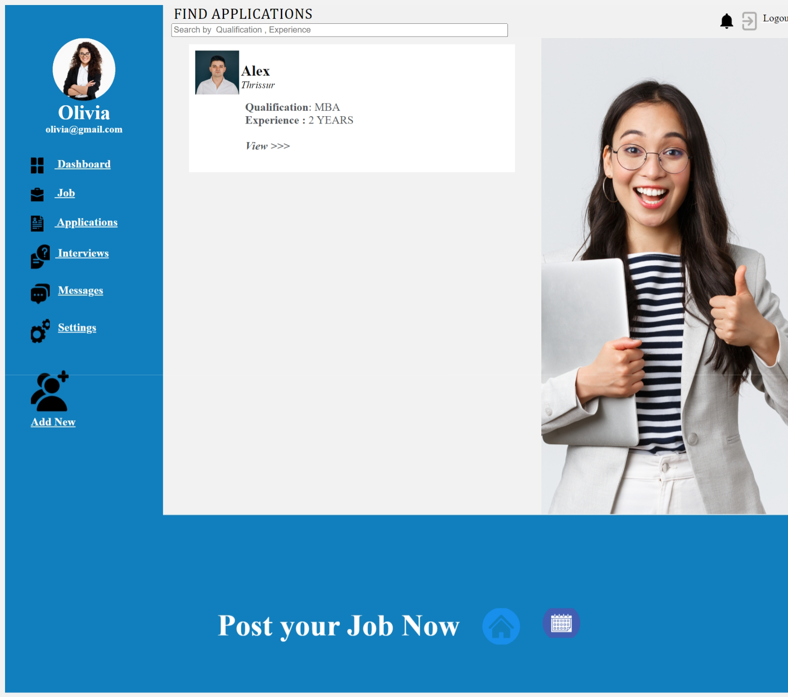

**Expected Output**

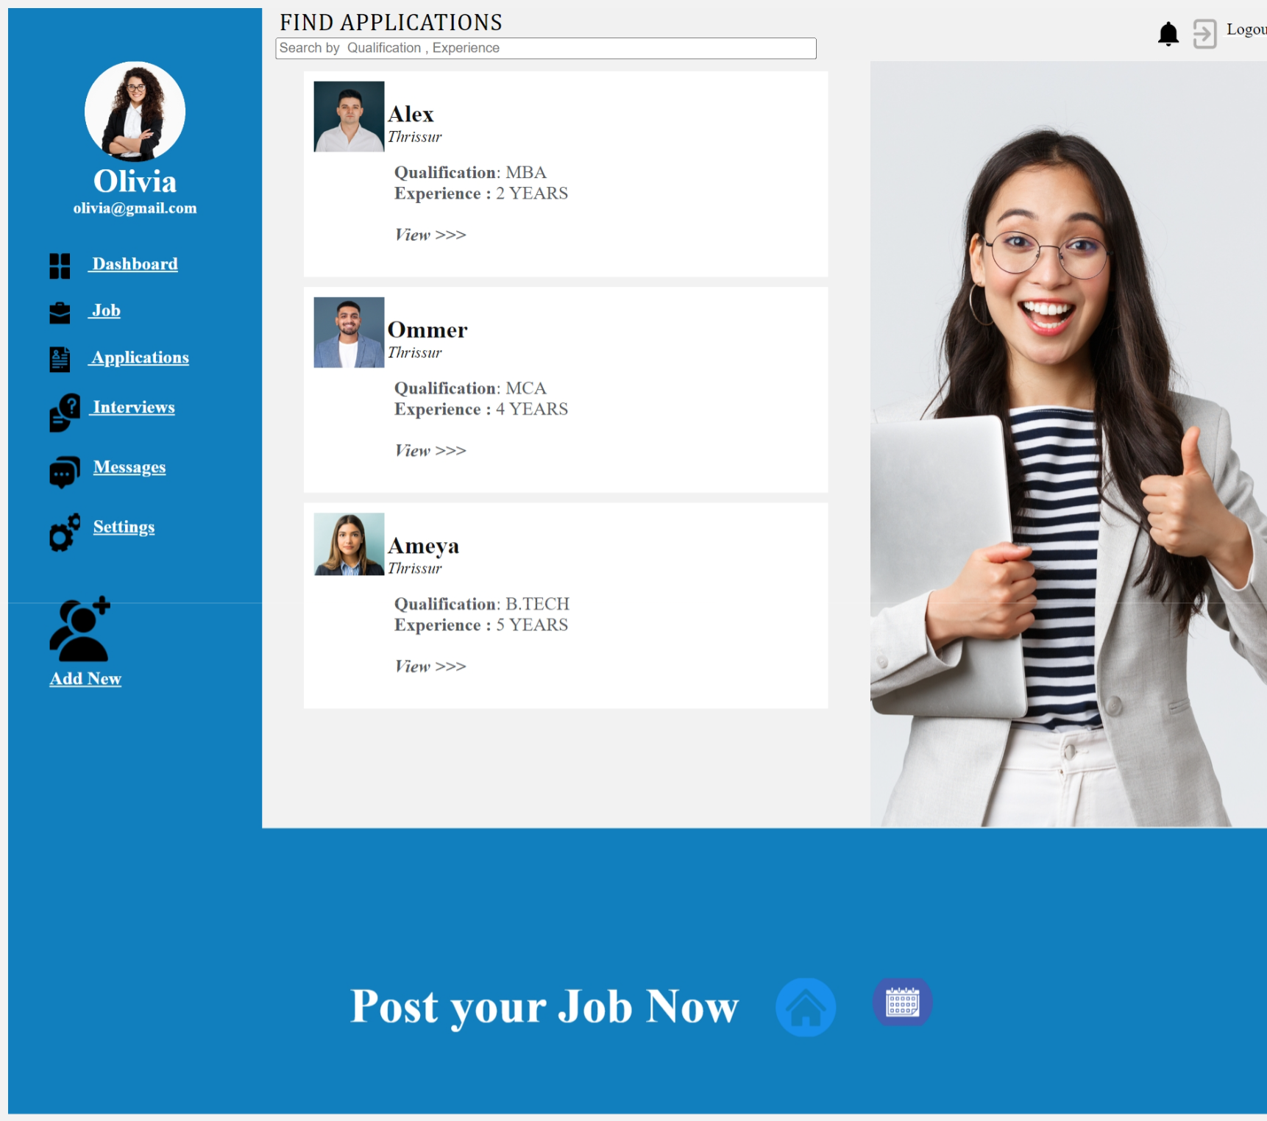

In HTML5, this code represents a webpage designed as a student workshop platform, with a title, author metadata, and favicon link in the `<head>` section. The `<body>` section sets background and link colours, and it uses a table structure to create different sections for the header, user profile information, potential content, and a footer with job-related actions and icons. The code includes image references with relative paths, and there are commented-out sections for possible future content or features.

**Workshop2**



**Expected Output**

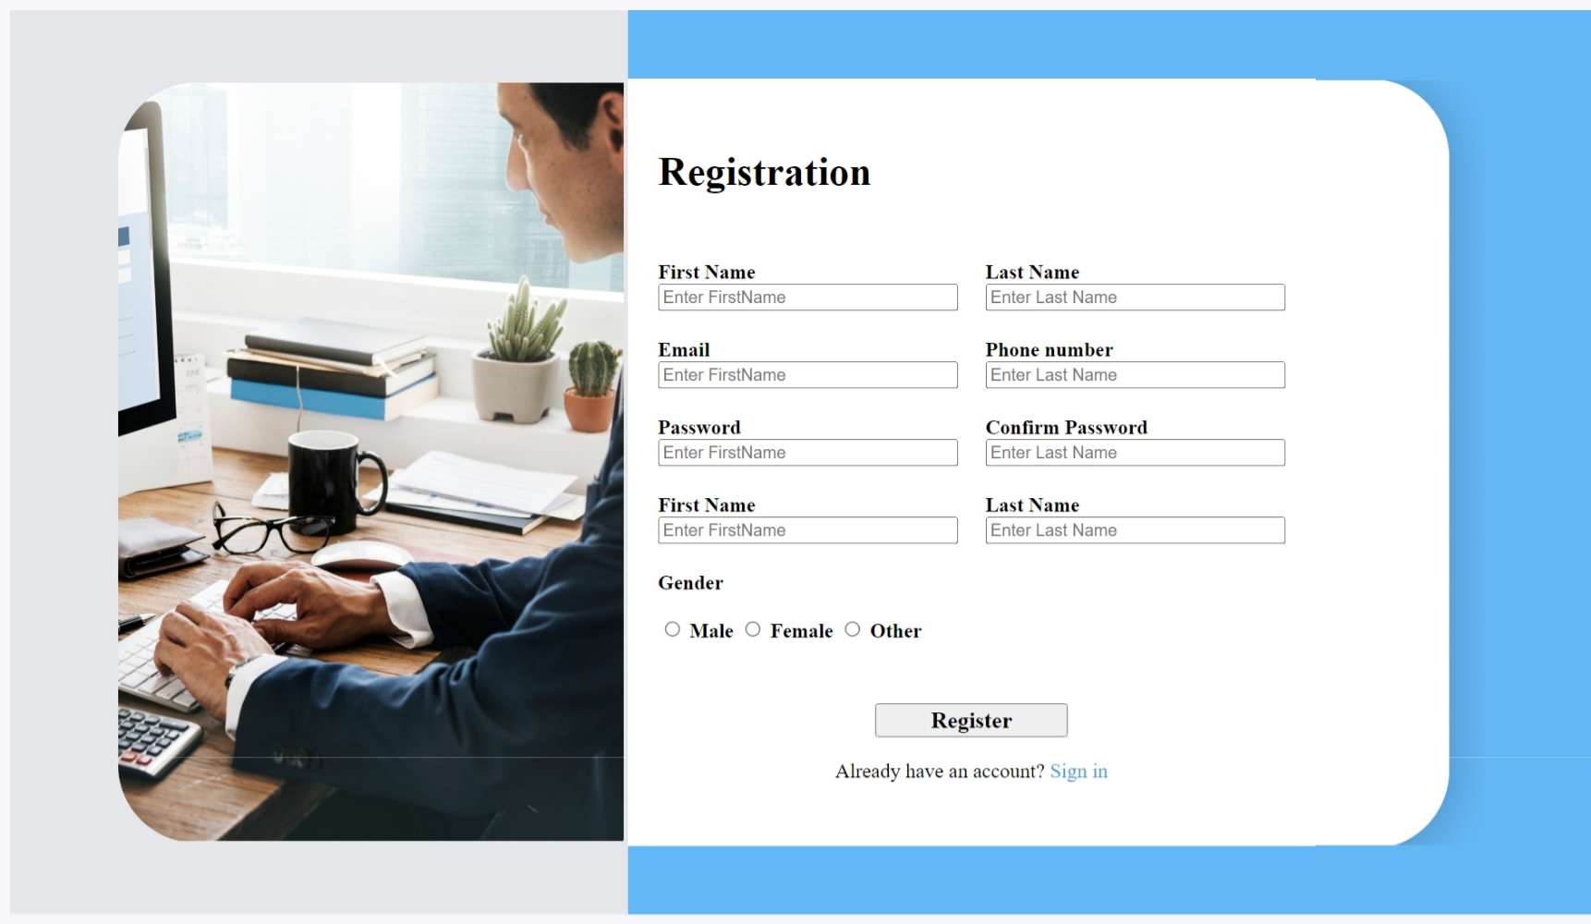

In HTML5, this code represents a student workshop webpage with the title "Workshop 2," author metadata, and a favicon link in the `<head>` section, defining the background and link colors in the `<body>`. The page utilizes a table structure to create distinct sections: a left column displaying an image, a center column for user registration with input fields for personal details,

gender selection, and a "Register" button, and a right column displaying another image. This HTML5 webpage serves as a registration form for students interested in the workshop, facilitating the submission of their information for sign-up.

**Workshop3**

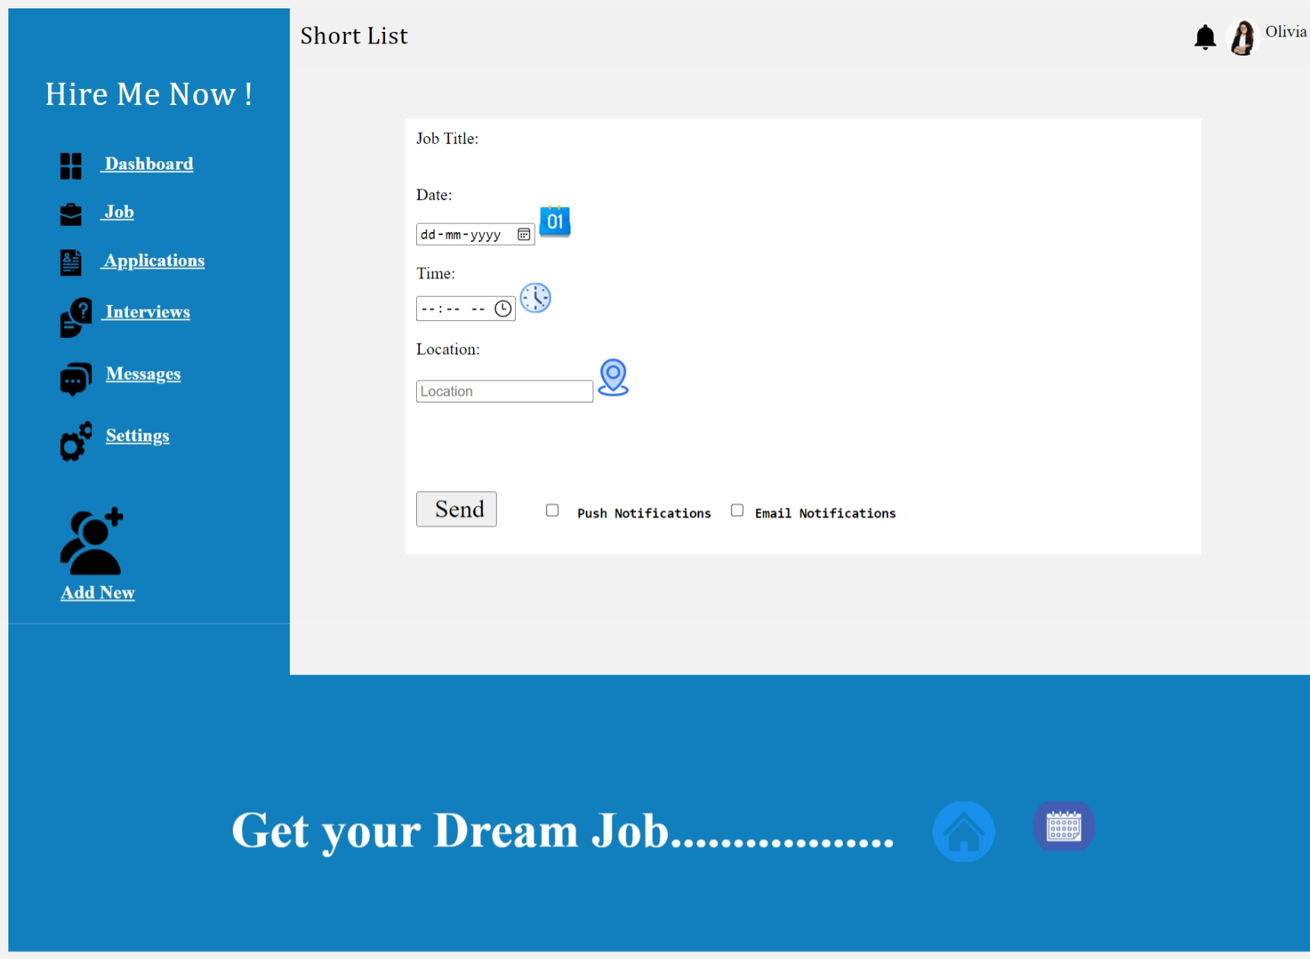

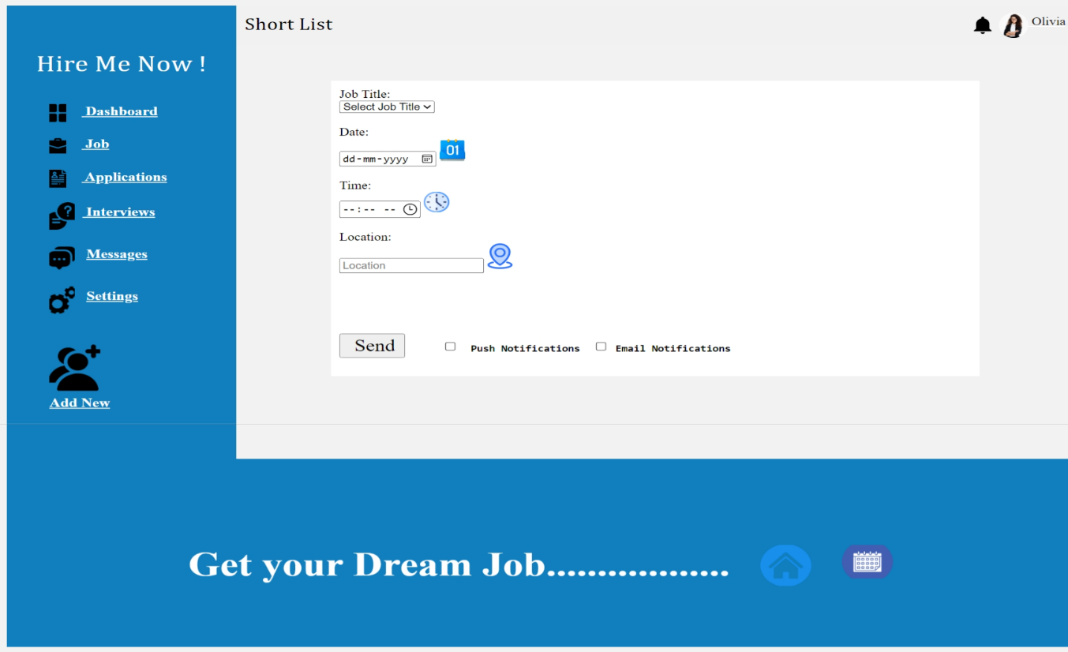**Expected Output**

This HTML5 code represents a student workshop webpage titled "Workshop 3," which includes author metadata and a favicon link in the `<head>`. In the `<body>`, it defines background and link colors and employs a table structure to create distinct sections: a header row with "Short List" as the title and user information, a left column with user profile and navigation links, a central column allowing users to select job-related details and notification preferences, and a right column for potential content. The footer row promotes dream job opportunities and includes navigation icons. This webpage is tailored for a student workshop, focusing on job-related activities and user engagement through a structured interface.

**Workshop4**

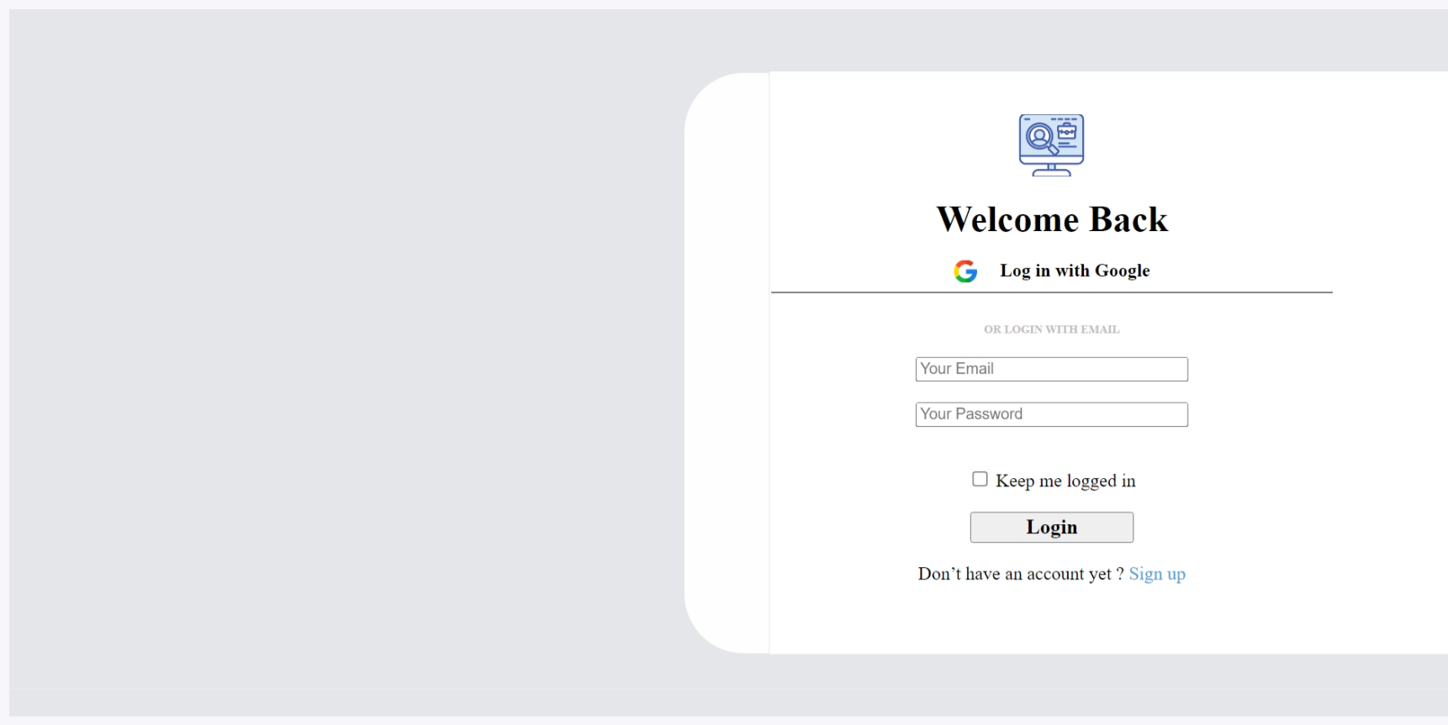

**Expected Output**

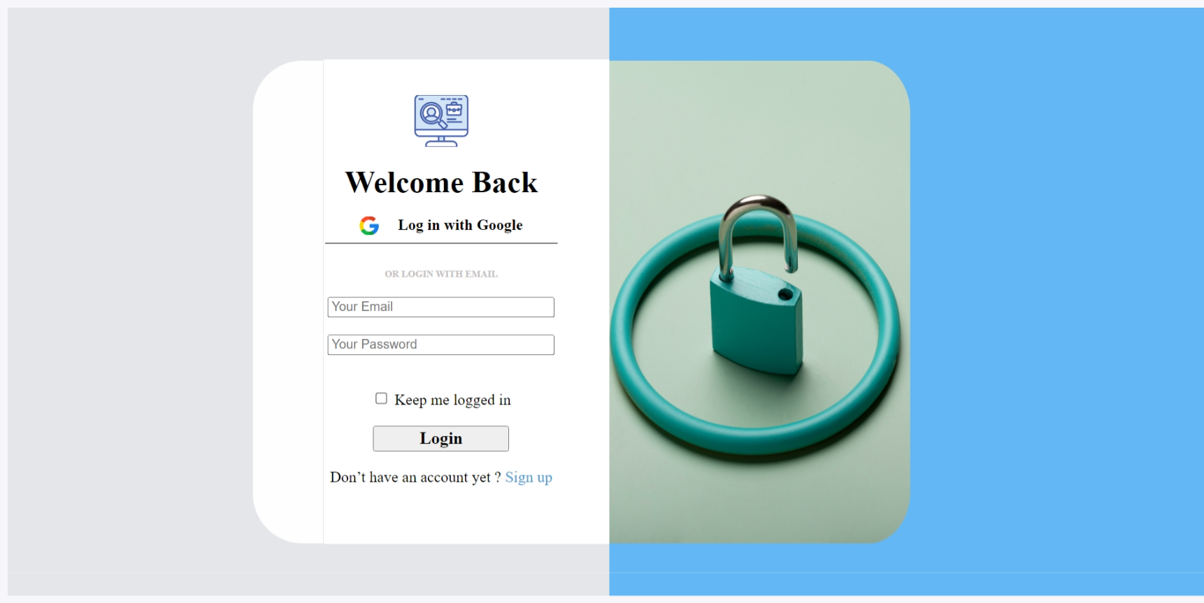

In HTML5, this code represents a student workshop webpage titled "Workshop 2" featuring a login portal with author metadata and a favicon link in the `<head>`. The `<body>` sets background and link colours, using a table structure to create two main sections:

1. The left column contains a login form offering options to log in with Google or an email account, allowing users to input their email and password, and providing a "Keep me logged in" option. A "Login" button is available, along with a link for users to sign up for a new account.

2. The right column displays an image for decorative purposes.

This webpage is designed to facilitate student logins and account creation for the workshop.

**Workshop5**

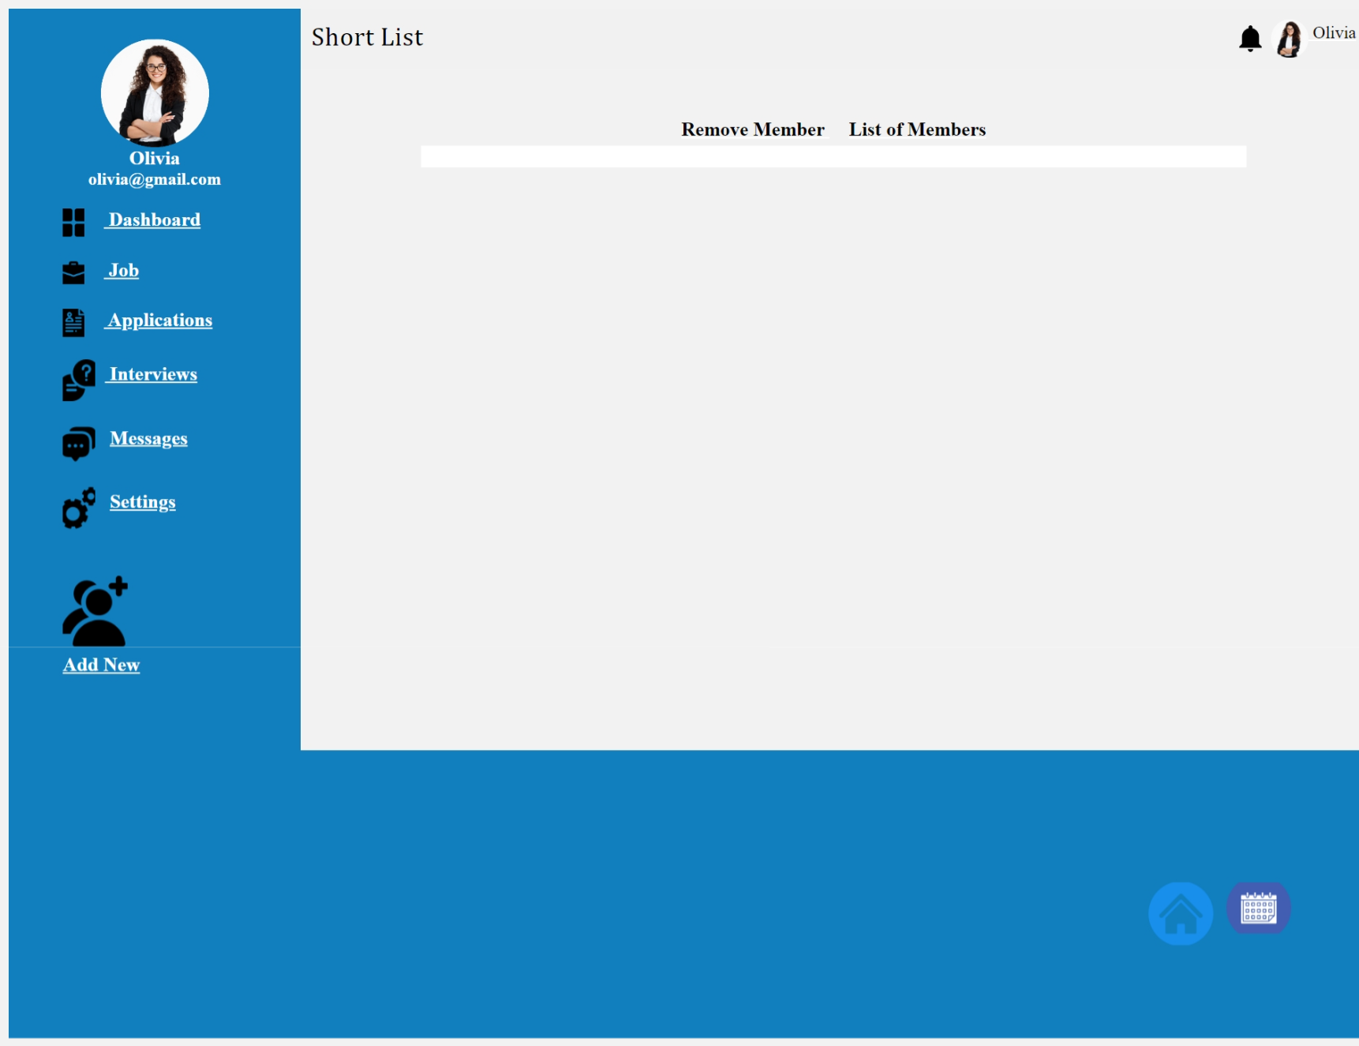

**Expected Output**

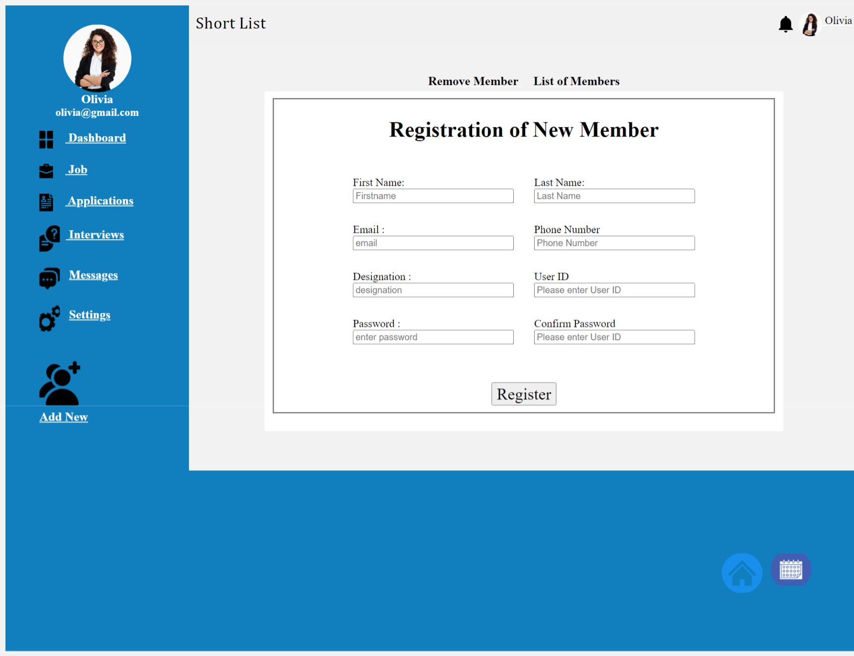

This HTML code represents a web page structure with a header containing profile information and navigation links, a registration form for new members in the main content section, and a footer with navigation icons, providing an overview of how HTML5 is used to create web pages.

**Conclusion**

HTML5 revolutionized web development with native support for multimedia, improved semantics, and enhanced form capabilities. It enabled rich graphics and animations through the `<canvas>` element and WebGL, transforming web gaming and visualization. Furthermore, HTML5's offline support with the Application Cache has made web apps more resilient in offline scenarios. Overall, HTML5 has ushered in a more dynamic, responsive, and engaging web experience.

<a href="registeration.html" ></a>

<img src="images/Background shape right.png" alt="" height="600px"width="700px">